Physics Year 11 : Formulae and Constants Sheet 2005

Area of Study: Movement
Average velocity | 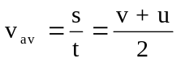
Acceleration | 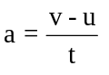
Momentum | 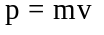
Force | 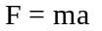
Weight | 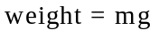
Work done | 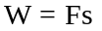
Kinetic energy | 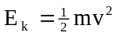
Gravitational potential energy | 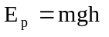
Equations of motion | 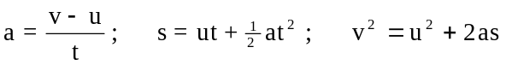
Impulse | 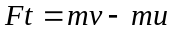 or 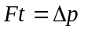
Power | 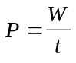
Momentum | P= mv

Area of Study: Heating and Cooling
Heat, Q, involved in a temperature change | 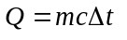
Power | 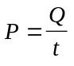
Heat, L, involved in a phase change | 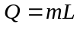

Area of Study: Electricity
Power | 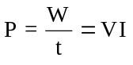
Electric current | 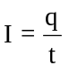
Work | 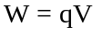
Ohm’s Law | 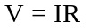
Resistances in Series | 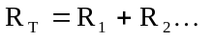
Resistances in Parallel | 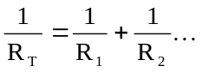
Electrical Energy | 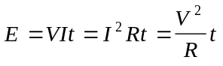
Resistivity | 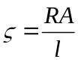
Coulomb's Law | 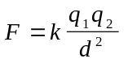

Area of Study: Nuclear Technology
Absorbed Dose | 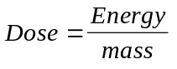
Dose Equivalent | Dose = Absorbed dose x Quality Factor
Einstein Equation | 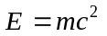  1 u = 931 MeV  1MeV = 1.60 x 10⁻¹³ J

Area of Study: Sight and Light
Snell’s Law | 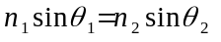
Critical Angle | 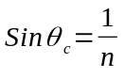
Refractive index for light travelling from medium 1 to medium 2 | 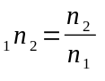
Absolute refractive index for light travelling in medium x. | 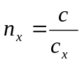
Lens Equation | 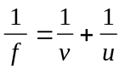
Magnification | 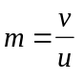
Physical Constants/Data
Speed of light in air c = 3.00 x 10⁸ m s⁻¹
Electron charge e = -1.60 x 10⁻¹⁹ C
Mass of electron m_{e} = 9.11 x 10⁻³¹ kg
Electron volt 1 eV = 1.60 x 10⁻¹⁹ J
Mass of proton m_{p} = 1.6726 x 10⁻²⁷ kg (1.00728 u)
Mass of neutron m_{n} = 1.6750 x 10⁻²⁷ kg (1.00867 u)
Nuclear mass of 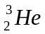 m = 5.00812 x 10⁻²⁷ kg (3.01603 u)

Acceleration due to gravity on earth | 9.80 ms⁻²
Room Temperature | 20ºC |  | Resistivity of Copper | 1.7 x 10⁻⁸ Ω m
Coulomb’s constant | 9.00 x 10⁹ N m² C⁻² |  | Resistivity of Tungsten | 5.5 x 10⁻⁸ Ω m
1 amu | 1.6605 x 10⁻²⁷ kg
Tonne | 1 tonne =1.00 x 10³ kg
Refractive index of air | 1.00

Specific Heat Capacity of selected substances
Substance |  | c (Jkg⁻¹K⁻¹) | Substance |  | c (Jkg⁻¹K⁻¹)
 | Water | 4.18 x 10³ |  | Glass | 8.40 x 10²
 | Steel (Stainless) | 4.50 x 10² |  | Ice | 2.10 x 10³
 | Lead | 1.26 x 10² |  | Human Body (Av) | 3.47 x 10³
 | Aluminium | 8.90 x 10² |  | Copper | 3.80 x 10²
 | Wood | 1.70 x 10³ |  | Mercury | 1.40 x 10²
 | Steam | 2.00 x 10³ |  | Ethyl Alcohol | 2.40 x 10³
 | Pewter | 1.43 x 10² |  | Air | 1.00 x 10³

Melting points and boiling points

Material | Melting Point (ºC) | Boiling Point (ºC)
Lead | 327 | 1750
Ethyl Alcohol | -114 | 78
Tungsten | 3410 | 5900
Silver | 961 | 2193

Specific latent heat of selected substances

Material | Phase change | Value (Jkg⁻¹)
Lead | Fusion | 2.50 x 10⁴
Ice | Fusion | 3.36 x 10⁵
Steam | Vaporisation | 2.27 x 10⁶
Lead | Fusion | 2.51 x 10⁴
Ethanol | Fusion | 1.65 x 10⁵

Weighting Factors
Radiation Type | Approximate Quality Factor
Gamma Ray | 1
Beta Particle | 1
Slow Neutron | 3
Fast Neutron | 10
Alpha Particle | 20

Absolute Index of Refractive ( for light of λ = 589 nm)

Medium | Index (n) | Medium | Index (n)
Vacuum | 1.0000 | Crown glass | 1.51
Air | 1.00029 | Flint glass | 1.65
Ice | 1.31 | Diamond | 2.42
Water | 1.33 | Perspex | 1.49
Quartz | 1.46 | Carbon disulfide | 1.63

Electromagnetic spectrum

 | Wavelength
λ (m) |  | 10² |  | 10 |  | 1 |  | 10⁻¹ |  | 10⁻² |  | 10⁻³ |  |  |  | 10⁻⁴ |  | 10⁻⁵ |  | 10⁻⁶ |  | 10⁻⁷ |  | 10⁻⁸ |  |  | 10⁻⁹ |  |  | 10⁻¹⁰ |  |  |  | 10⁻¹¹
microwaves
radio frequencies
infrared radiation
ultraviolet
radiation
X-rays
gamma rays


Area of
Spectrum
f(Hz) | 10⁶ |  | 10⁷ |  | 10⁸ |  | 10⁹ |  | 10¹⁰ |  | 10¹¹ |  |  | 10¹² |  |  | 10¹³ |  | 10¹⁴ |  | 10¹⁵ |  | 10¹⁶ |  | 10¹⁷ |  |  |  | 10¹⁸ |  |  | 10¹⁹ |  |  |  | 10²⁰
 | Frequency

Note: 1. Shaded areas represent regions of overlap. 2. Gamma rays and X-rays occupy a common region.

Mathematical expressions
B
c
a
Given ax² + bx + c = 0, 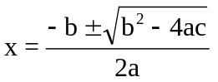
b
A
C

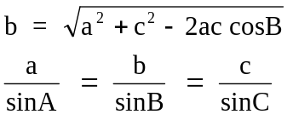

Prefixes of the Metric System

Factor | Prefix | Symbol | Factor | Prefix | Symbol
10¹²  10⁹  10⁶  10³ | tera  giga  mega  kilo | T  G  M  k | 10⁻³  10⁻⁶  10⁻⁹  10⁻¹² | milli  micro  nano  pico | m  µ  n  p

Table of Nuclear Rest Masses

Particle | Mass (u) | Mass (kg)
Electron/positron | 0.000549 | 9.11 x 10⁻³¹
Proton/hydrogen | 1.00728 | 1.6726 x 10⁻²⁷
Neutron | 1.00867 | 1.6750 x 10⁻²⁷
Americium-241 | 241.05862 | 4.0018 x 10⁻²⁵
Deuterium | 2.01350 | 3.3435 x 10⁻²⁷
Carbon-12 | 11.99671 | 1.99213 x 10⁻²⁶
Carbon-14 | 13.99923 | 2.32478 x 10⁻²⁶
Helium–4 | 4.00260 | 6.64632 x 10⁻²⁷
Neptunium–237 | 237.04817 | 3.93619 x 10⁻²⁵
Thorium-234 | 233.98418 | 3.88545 x 10⁻²⁵
Uranium-238 | 238.00028 | 3.95214 x 10⁻²⁵
Plutonium-239 | 239.001158 | 3.96885 x 10⁻²⁵

